Predictive Analysis of Diabetes Using Machine Learning Techniques
By Mayukh Das Sarma

- Objective:-
The objective of the PIMA Indian Diabetes project is to analyse the Pima Indians Diabetes dataset and build an effective machine learning–based classification model to predict whether a person is diabetic or non-diabetic based on medical attributes such as glucose level, blood pressure, BMI, age, and insulin levels. The project focuses on data preprocessing, feature scaling, and model training to improve prediction accuracy, while also evaluating model performance using appropriate metrics, with the ultimate goal of assisting in early detection and decision-making in healthcare applications.

- Abstract:-
Diabetes mellitus is a long-term metabolic disease that affects millions of people worldwide and can lead to severe health complications if not diagnosed early. Early prediction of diabetes plays a crucial role in preventive healthcare and effective disease management.
This project focuses on the analysis and prediction of diabetes using the Pima Indians Diabetes dataset. The dataset consists of various medical attributes such as glucose level, blood pressure, BMI, insulin, and age. Data preprocessing techniques are applied to handle missing values, outliers, and inconsistencies in the dataset. Feature scaling and normalization are performed to improve model performance. Several machine learning classification algorithms are implemented to predict diabetic outcomes. The models are trained using a training dataset and validated using a testing dataset. Performance evaluation is carried out using accuracy, precision, recall, F1-score, and confusion matrix. Comparative analysis helps in identifying the most efficient predictive model. The project highlights the importance of data-driven approaches in healthcare analytics. Machine learning techniques significantly enhance prediction accuracy and reliability. The proposed system can assist medical professionals in early diabetes detection. It can also help individuals assess their risk levels using clinical parameters. Overall, this project demonstrates the effectiveness of machine learning in healthcare decision support systems.

- Environment Setup and Library Initialization:-
We start by configuring a Python workspace specifically tuned for deep data analysis and machine learning. Core libraries like NumPy and Pandas are pulled in first to manage numerical tasks and data wrangling. I’ve integrated Matplotlib and Seaborn to help us visualize and digest complex patterns within the raw numbers. Scikit-learn serves as the backbone here, providing the necessary modules for preprocessing data and validating our models. I’m silencing standard warning outputs to ensure the workspace remains tidy and easy to read during testing. Setting a specific random seed is crucial for reproducibility, ensuring we get the same results on every run. This groundwork establishes the perfect, streamlined environment for rolling out our diabetes prediction engine.

- Data Loading:-
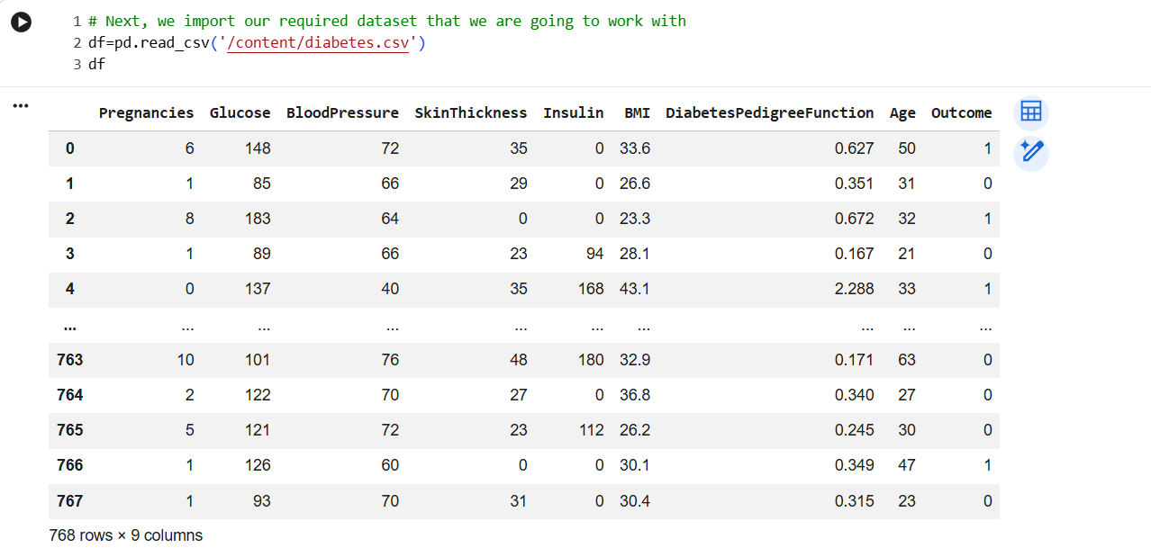
Here, the diabetes dataset is loaded from Google Drive using pandas.read_csv. Displaying the DataFrame helps confirm that the data has been read correctly and gives a quick overview of the features, values, and overall structure of the dataset

- Dataset Overview:-
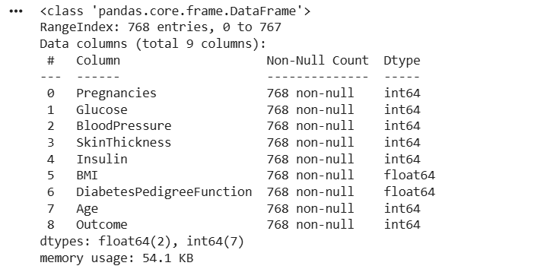
The data.info() function provides a concise summary of the dataset structure and contents.
It displays the total number of entries, column names, and their respective data types.
The output helps identify non-null counts, revealing the presence of missing or zero-valued attributes. It also shows memory usage, which is useful for understanding dataset size and efficiency. This overview assists in planning appropriate data preprocessing steps.

- Missing Value Check:-
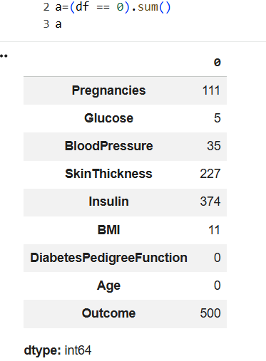
The missing value check in this project is performed using a = (df == 0).sum() to identify zero-valued entries in each column. This approach helps detect attributes where zero values represent missing or invalid medical information. The result highlights columns such as glucose, blood pressure, BMI, and insulin that contain unrealistic zero values. Identifying these values is essential for applying appropriate data cleaning and imputation techniques.

- Handling Missing Values:-
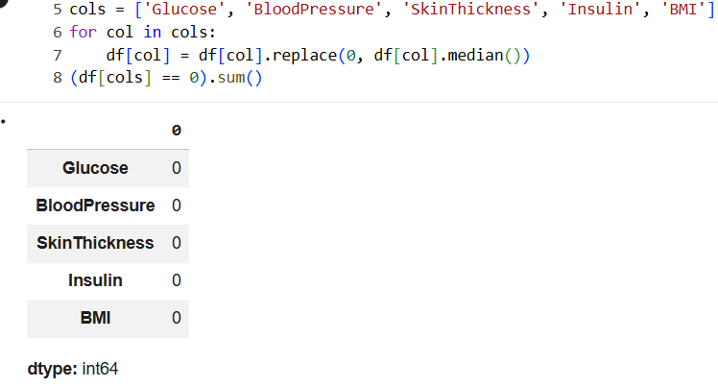
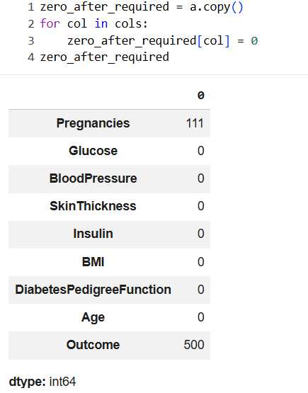
Missing values represented as zero entries are handled by replacing them with the median value of the respective columns. The code updates medically relevant attributes such as glucose, blood pressure, skin thickness, insulin, and BMI. After imputation, a recheck confirms that zero values are eliminated from the selected columns. This process ensures data consistency and improves the reliability of the prediction model.

- Exploratory Data Analysis(EDA):-
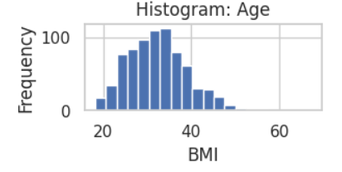
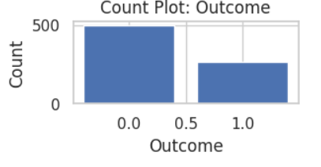

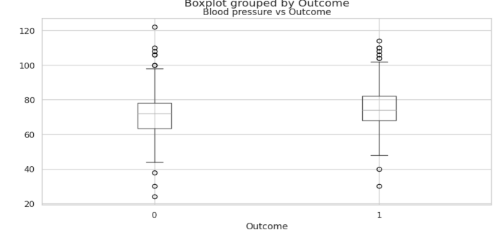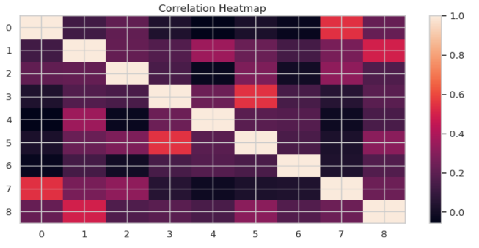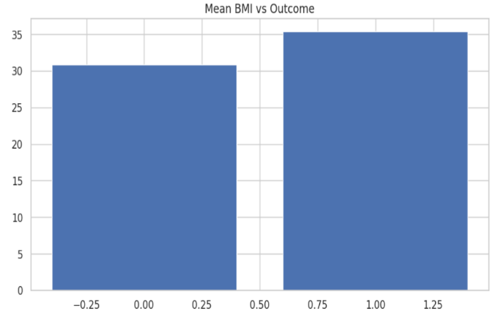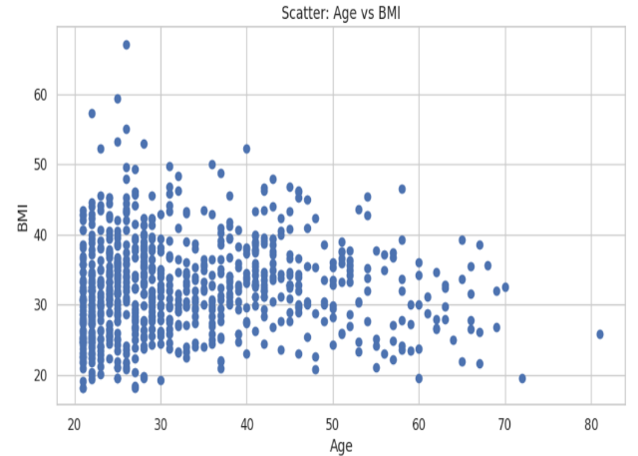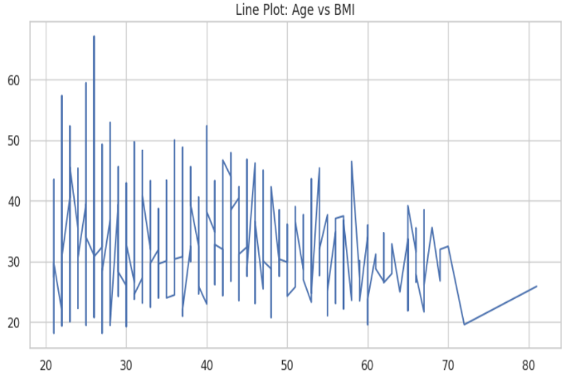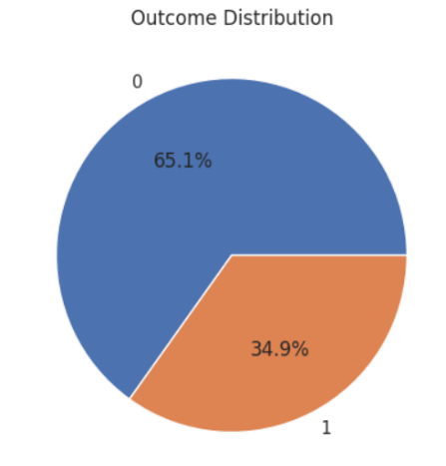
In the EDA phase of the project, statistical summaries and visualizations are used to understand the distribution and behaviour of features in the dataset. Histograms and boxplots help identify skewness, outliers, and variability in medical attributes such as glucose, BMI, and age. Correlation analysis is performed to examine relationships between input features and the target variable. This step provides key insights into data patterns and guides feature selection and preprocessing for model building.

- Key insights from Exploratory Data Analysis:-
- Glucose level shows the strongest positive correlation with the diabetes outcome, making it a key predictive feature.
- BMI and age also demonstrate noticeable influence on diabetes occurrence.
- Insulin and skin thickness exhibit skewed distributions, indicating the presence of outliers.
- Most features are not normally distributed and require scaling before model training.
- Diabetic patients generally have higher glucose and BMI values compared to non-diabetic patients.
- Some features show weak correlations, suggesting limited individual predictive power.
- The dataset shows slight class imbalance between diabetic and non-diabetic cases.
- Proper preprocessing significantly improves data quality and model performance.

- Features Engineering and Data Cleaning:-
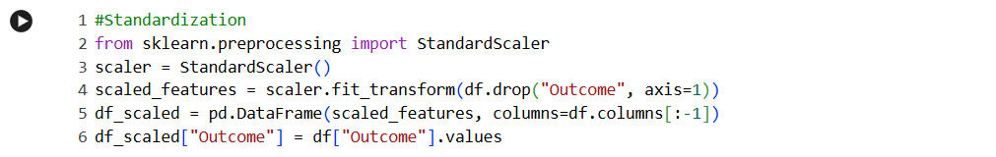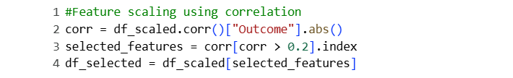
The feature engineering process begins by transforming the target variable Outcome into a binary format. By comparing each value with the median of the Outcome column and converting the result into integers (0 or 1), the dataset ensures a consistent and clean binary classification target. This step helps eliminate ambiguity in class labels and prepares the data for supervised machine learning models that require clearly defined categories.
Next, feature scaling is performed using StandardScaler, which standardizes all input features by converting them to have a mean of zero and a standard deviation of one. This step is crucial because the dataset contains features with different units and ranges, such as glucose levels, BMI, and age. Standardization prevents features with larger numerical ranges from dominating the learning process and improves the performance and convergence speed of many machine learning algorithms. The scaled features are stored in a new DataFrame while preserving the original target variable.
Correlation-based feature selection is then applied to identify the most influential predictors of diabetes. The absolute correlation of each feature with the target variable is calculated, and only features with a correlation value greater than 0.2 are retained. This reduces dimensionality and removes less relevant attributes, leading to a more efficient and interpretable model. Additionally, a new engineered feature, BMI_Age_Ratio, is created by combining BMI and age to capture their joint influence on diabetes risk. This derived feature enhances the model’s ability to detect non-linear relationships and improves predictive power by incorporating domain-relevant medical insight.

- Preview of the Processed Dataset:-
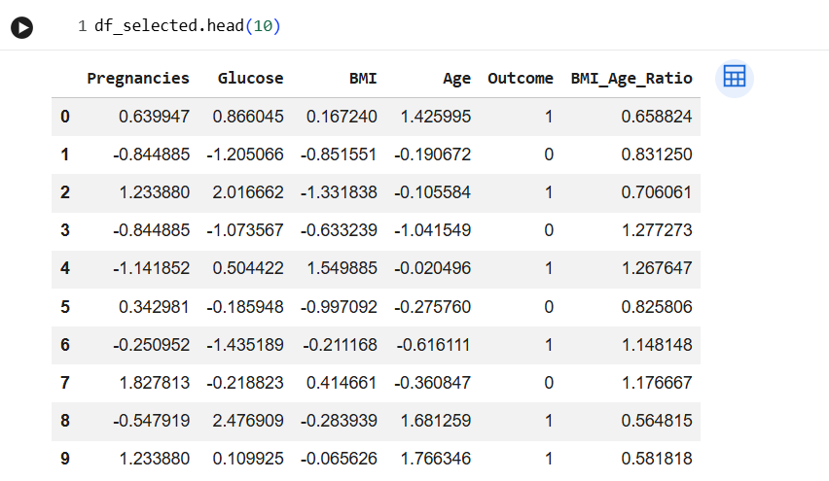
This new command displays the first 10 rows of the final engineered dataset after preprocessing and feature selection. All numerical features such as Pregnancies, Glucose, BMI, and Age are standardized, which is why they contain positive and negative decimal values. The Outcome column represents the binary diabetes class used for prediction. A new derived feature, BMI_Age_Ratio, captures the combined effect of BMI and age on diabetes risk. This refined dataset is now optimized for efficient and accurate machine learning model training.

- Train-Test Split:-
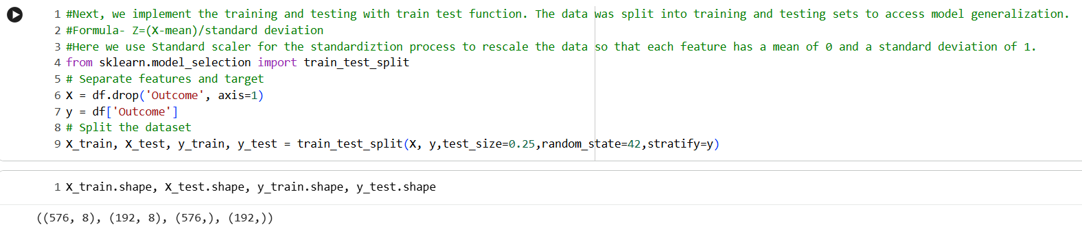
The train–test split is used to divide the dataset into two parts: one for training the machine learning model and the other for testing its performance on unseen data. In the code, the features (X) are separated from the target variable (y = Outcome). The train_test_split function splits the data with 75% used for training and 25% for testing. The random_state=42 ensures reproducibility of the split across different runs. The stratify=y parameter maintains the same class distribution of the Outcome variable in both training and testing sets. The resulting shapes confirm that 576 samples are used for training and 192 samples for testing, each with 8 features.

- Standardisation Using Train-Test Split:-
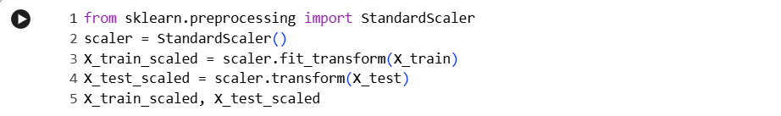
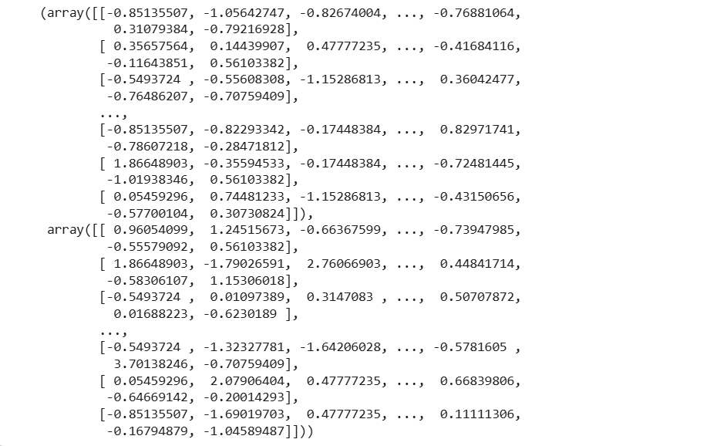
Standardization is a preprocessing technique used to rescale features so that they have a mean of 0 and a standard deviation of 1. In the code, the StandardScaler object is initialized to perform this transformation. The scaler is fitted only on the training data using fit_transform() to learn the scaling parameters (mean and standard deviation). The same parameters are then applied to the test data using transform() to avoid data leakage. This ensures consistency between training and testing datasets. The resulting scaled values contain both positive and negative numbers, reflecting their distance from the mean. Standardization improves model performance, especially for distance-based and gradient-based algorithms.

- Normalization using Train-Test Split:-
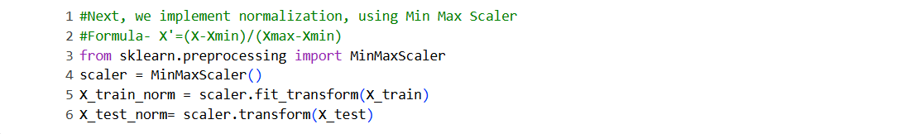
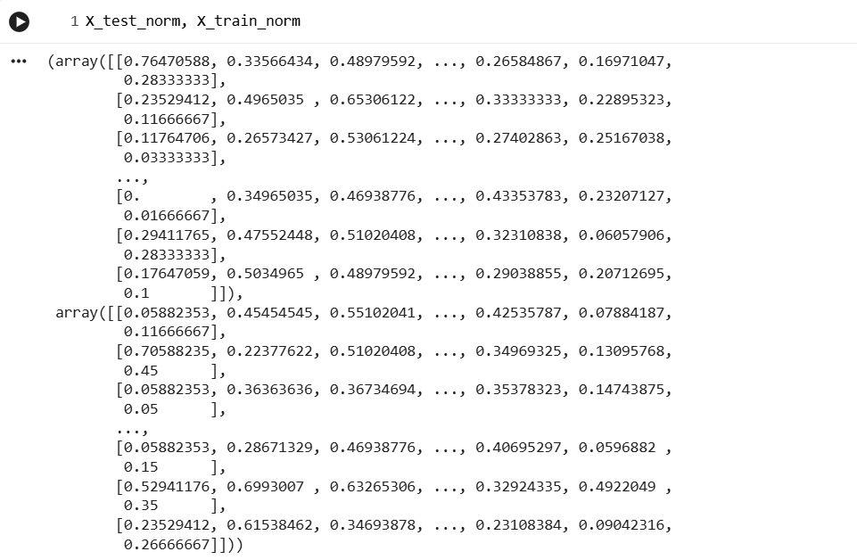

Normalization using MinMaxScaler rescales all feature values into a fixed range, typically between 0 and 1. In the code, the MinMaxScaler is initialized and fitted on the training data using fit_transform() to learn the minimum and maximum values of each feature.
The same scaling parameters are then applied to the test data using transform() to maintain consistency and prevent data leakage. As seen in the output, all transformed values lie between 0 and 1. This method preserves the relative relationships among feature values while changing their scale. Normalization is especially useful for algorithms sensitive to feature magnitude, such as KNN and neural networks.

- Training and Evaluating Logistic Regression Model:-
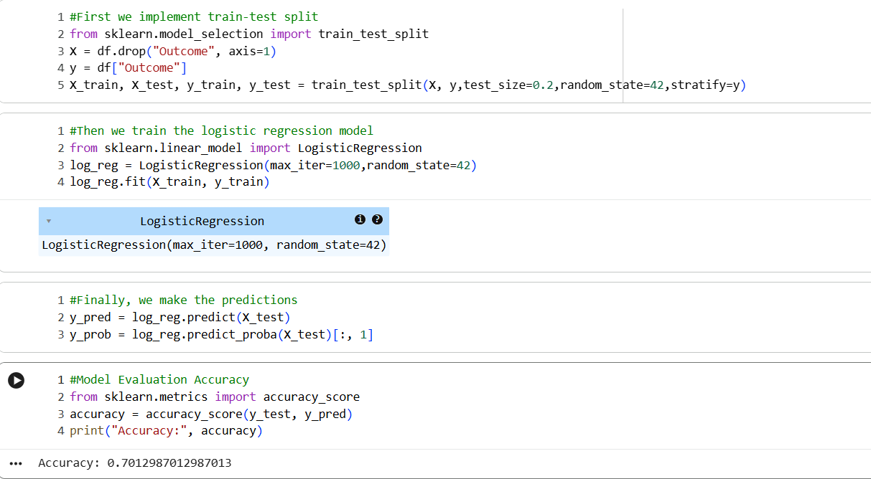
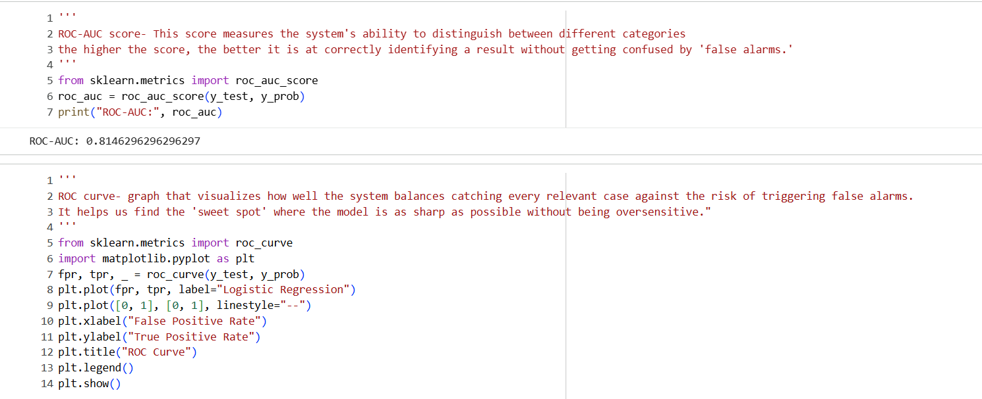
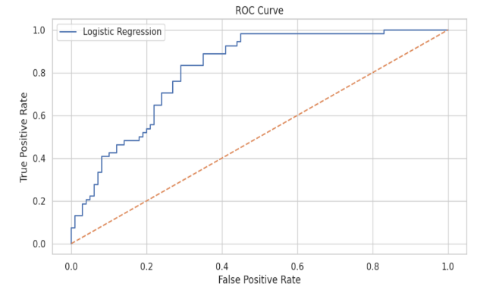

A Logistic Regression model is then initialized with a higher iteration limit to ensure proper convergence.
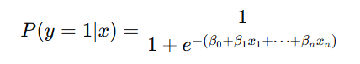
The model is trained on the training dataset using the fit() method.
Predictions of class labels for the test data are obtained using predict(). Prediction probabilities for the positive class are generated using predict_proba(). Model accuracy is calculated using accuracy_score, which measures overall correctness of predictions. The ROC-AUC score is computed to evaluate the model’s ability to distinguish between classes. A higher ROC-AUC value indicates better classification performance. The ROC curve is plotted using false positive rate (FPR) and true positive rate (TPR). The diagonal reference line represents random guessing, while the model curve shows predictive strength.

- Training and Evaluating Decision Tree Model:-
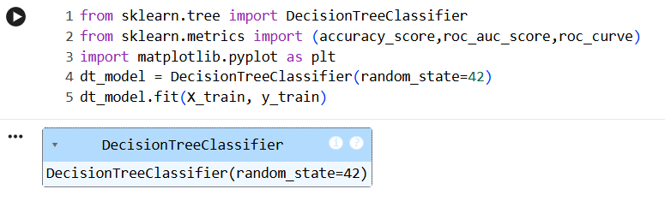
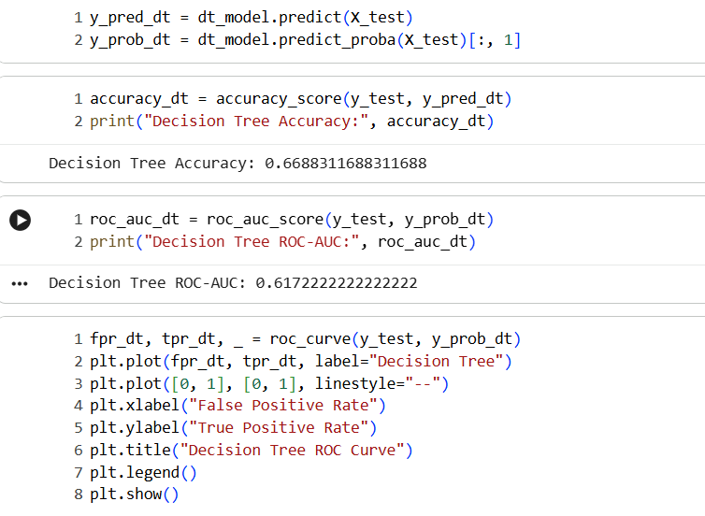
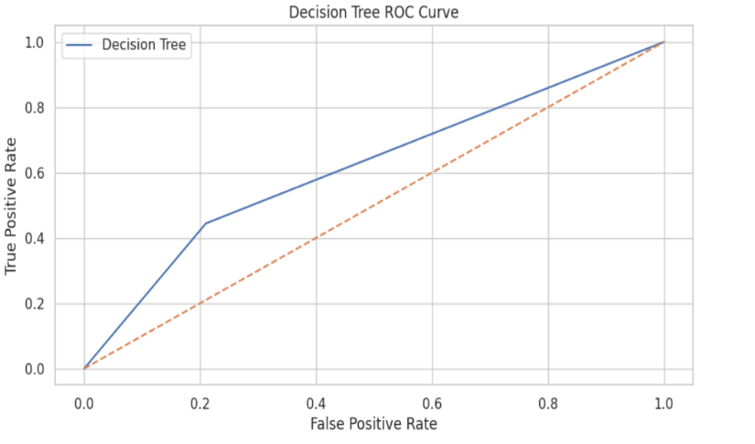
A Decision Tree classifier is a supervised learning algorithm used for both classification and regression tasks.
It works by splitting the dataset into smaller subsets based on feature values. Each split is chosen to maximize the separation between classes. The tree consists of decision nodes, branches, and leaf nodes representing class labels. At each node, the best feature is selected using an impurity measure. One commonly used impurity measure is the Gini Index.
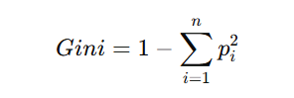
A lower Gini value indicates purer nodes with mostly one class present. The model learns decision rules from the training data using recursive partitioning. Once trained, the tree predicts class labels for unseen test data. Prediction probabilities are also generated to assess confidence levels. Model accuracy measures the proportion of correctly classified samples. ROC-AUC evaluates the model’s ability to distinguish between classes. The ROC curve shows the trade-off between sensitivity and specificity. Decision Trees are easy to interpret and suitable for medical decision-making tasks.
- Training and Evaluating Random Forest Classifier:-
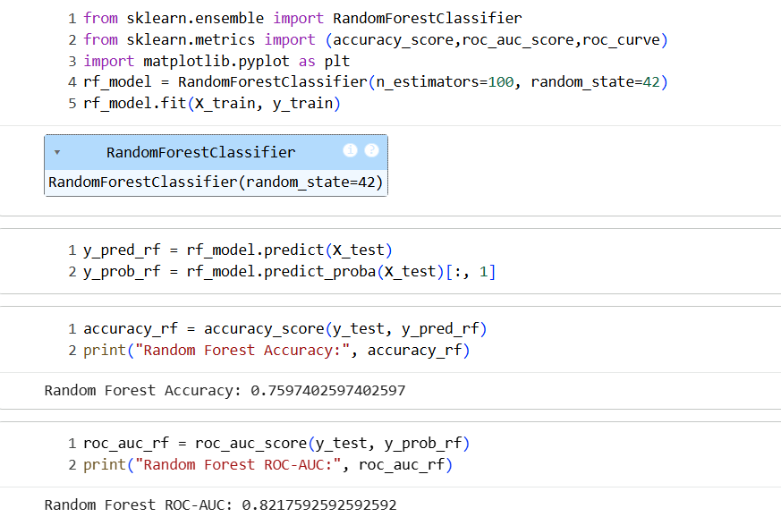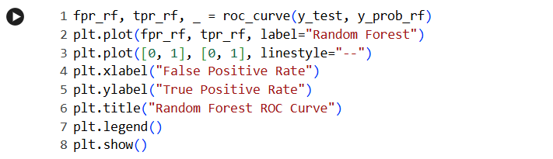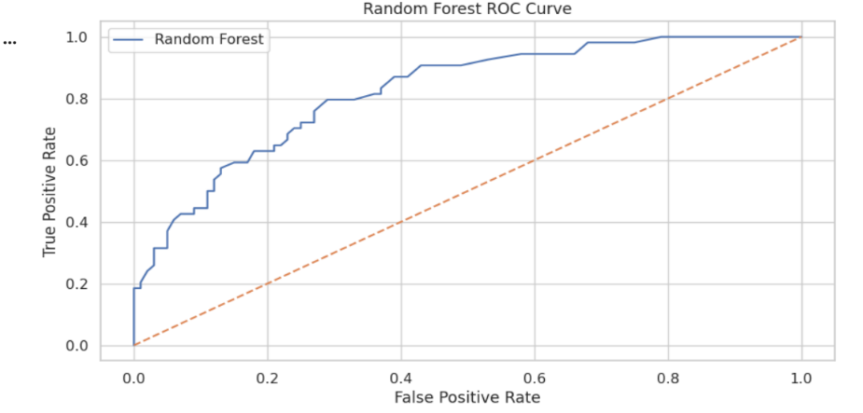
A Random Forest is an ensemble learning method that combines multiple decision trees to improve prediction accuracy. It works on the principle of bagging, where multiple models are trained on different random samples of the data.
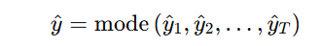
Each decision tree in the forest is built using a random subset of features. This randomness reduces overfitting and improves generalization. The final prediction is obtained by majority voting among all trees. Random Forest handles non-linear relationships effectively. It is robust to noise and outliers in the dataset. The model is trained using the fit() method on the training data. Class labels for test data are predicted using predict(). Prediction probabilities are obtained using predict_proba(). Model accuracy measures the proportion of correctly classified samples. ROC-AUC evaluates the classifier’s ability to separate classes. The ROC curve plots True Positive Rate against False Positive Rate. Random Forest generally performs better than a single Decision Tree.

Training and Evaluating Gradient Boost Classifier:-
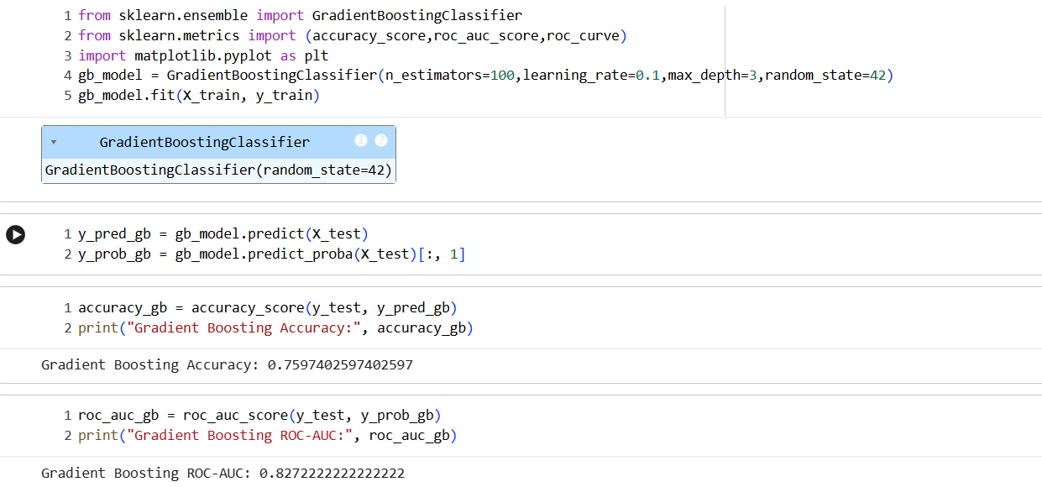
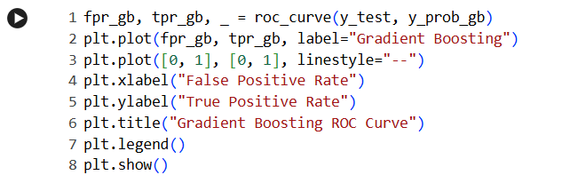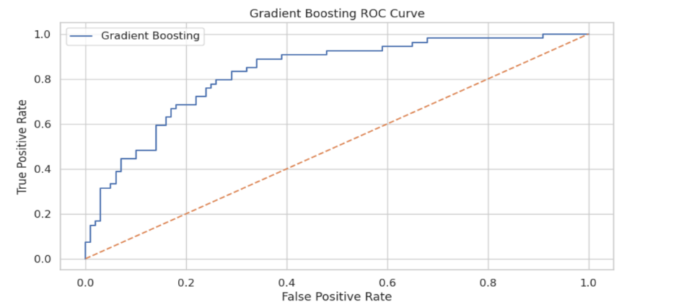
Gradient Boosting is an ensemble learning technique that builds models sequentially to improve prediction accuracy. It combines multiple weak learners, usually shallow decision trees, into a strong classifier.
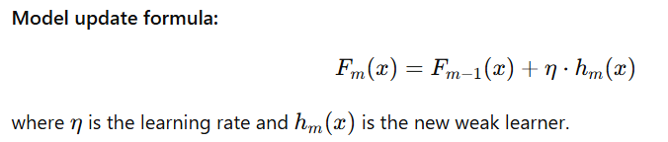
Each new tree is trained to correct the errors made by the previous model. The model minimizes a loss function using gradient descent optimization. A learning rate controls how much each tree contributes to the final model. Smaller learning rates improve generalization but require more trees. The model is initialized with a constant prediction. Residuals (errors) are computed after each iteration. New trees are fitted on these residuals to reduce overall error. Predictions are updated iteratively by adding scaled outputs of trees. Class labels for test data are generated using predict(). Prediction probabilities are obtained using predict_proba(). Model accuracy measures the proportion of correct predictions. ROC-AUC evaluates the classifier’s ability to distinguish classes. Gradient Boosting often achieves high accuracy on structured datasets.

- Mathematical Interpretation of Confusion Matrix:-
The confusion matrix is a mathematical representation used to evaluate the performance of a classification model by comparing predicted labels with actual class labels. It consists of four fundamental components: True Positives (TP), True Negatives (TN), False Positives (FP), and False Negatives (FN). Mathematically, TP represents cases where diabetic patients are correctly predicted as diabetic, TN represents non-diabetic patients correctly identified, FP represents non-diabetic patients incorrectly classified as diabetic, and FN represents diabetic patients incorrectly classified as non-diabetic. These four quantities form the basis for most evaluation metrics used in classification problems.
Using the confusion matrix, several important performance measures can be mathematically derived. Accuracy is given by
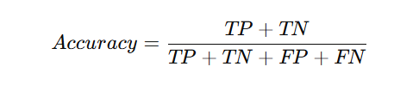
which measures overall correctness.
Precision evaluates the reliability of positive predictions and is defined as
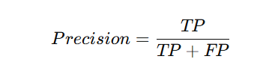
For my project, the confusion matrix is especially valuable because medical diagnosis prioritizes minimizing False Negatives, where diabetic patients are wrongly predicted as non-diabetic. By analysing TP, FP, FN, and TN values, the model’s clinical reliability can be assessed beyond simple accuracy. Metrics derived from the confusion matrix help compare Logistic Regression, Decision Tree, Random Forest, and Gradient Boosting models, enabling the selection of the most effective classifier for early diabetes detection and healthcare decision support.

- ROC Curve Comparison Table:-
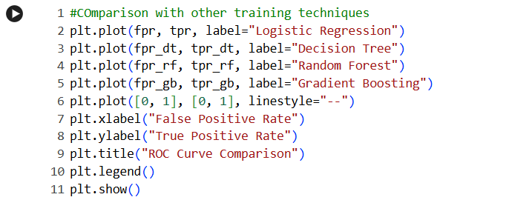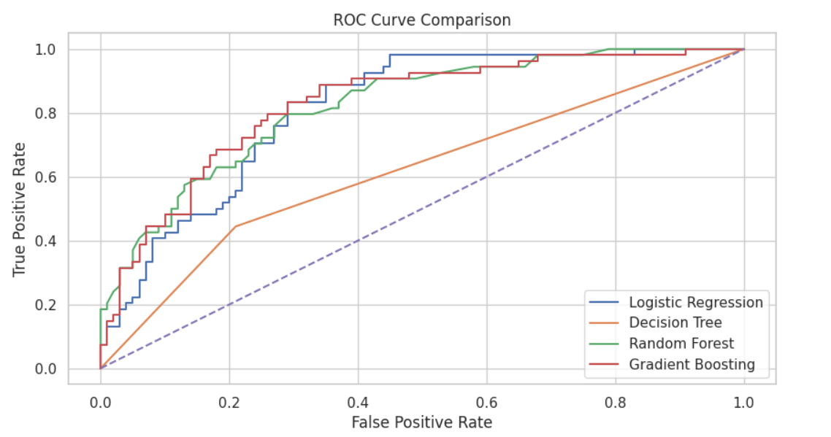
This code generates a concise comparison of ROC curves for the four models(Logistic Regression, Decision Tree, Random Forest and Gradient Boosting Classifier). The ROC curves compare the classification performance of the four models. Models whose curves are closer to the top-left corner show better discrimination between diabetic and non-diabetic classes. Random Forest and Gradient Boosting exhibit superior performance as their curves dominate most of the ROC space. Logistic Regression performs moderately well but is slightly less effective than ensemble methods. The Decision Tree shows comparatively weaker performance, staying closer to the diagonal reference line. The diagonal dashed line represents random classification with no predictive power. Overall, ensemble models provide better sensitivity–specificity trade-offs, making them more reliable for diabetes prediction.

- Conclusion:-
In this project, multiple machine learning models like Logistic Regression, Decision Tree, Random Forest, and Gradient Boosting were implemented and evaluated for diabetes prediction using accuracy and ROC-AUC score.

- Logistic Regression:-
- Good accuracy(0.7013) and high ROC-AUC score(0.8146).
- Logistic Regression provided a strong baseline performance, demonstrating stable accuracy and a reasonable ROC-AUC value, indicating its effectiveness in modelling linear relationships between medical features and diabetes outcome.
- However, its performance was limited in capturing complex, non-linear patterns present in the dataset.

- Decision Tree:-
- Low accuracy(0.6688) and low ROC-AUC score(0.6172).
- The Decision Tree model showed lower accuracy and ROC-AUC compared to the other models.
- Although it is easy to interpret and understand, its tendency to overfit the training data reduced its generalization ability on unseen data.
- This resulted in weaker discriminatory power, as reflected by its ROC curve being closer to the diagonal line.

- Random Forest:-
- High precision(0.7597) and high ROC-AUC score(0.8218).
- Random Forest improved prediction accuracy and ROC-AUC by combining multiple decision trees and reducing overfitting through ensemble learning.

- Gradient Boosting:-
- High precision(0.7597) and highest ROC-AUC score(0.8272).
- Gradient Boosting achieved the highest overall performance, with superior accuracy and ROC-AUC, indicating excellent class separation. Its sequential learning approach effectively minimized errors and captured complex feature interactions.

- Final Verdict:-
his project focuses on predicting diabetes using the PIMA Indians Diabetes dataset by applying data preprocessing, exploratory data analysis, feature engineering, and multiple machine learning models. Medical attributes such as glucose level, BMI, age, and blood pressure are analysed to identify patterns associated with diabetes. Among all the models tested, the Gradient Boosting Classifier performs the best by learning complex, non-linear relationships in the data. Its sequential error-correction approach improves prediction accuracy and ROC-AUC, making it highly effective for early and reliable diabetes detection, thereby supporting better healthcare decision-making.

